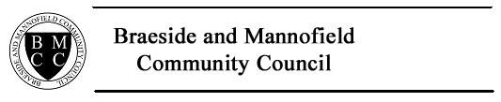

ANNUAL GENERAL MEETING
TUESDAY 25 FEBRUARY 2020, 7.00PM,
The Countesswells Room, MANNOFIELD PARISH CHURCH

AGENDA

- OPENING REMARKS

- APOLOGIES

- CHAIR’S REPORT

- TREASURER’S REPORT

- ANY OTHER COMPETENT BUSINESS

MEETING CLOSURE

